**Basic Linux Commands**

# Note: If we are running our commands in our personal username use sudo before all commands

The **sudo command** allows you to **run** programs with the security privileges of another user (by default, as the superuser). It prompts you for your personal password and confirms your request to execute a **command** by checking a file, called **sudoers**, which the system administrator configures.

# Creating empty file: (touch)

$ touch “filename”





# Listing files: (ls)

$ ls

This command lists all the files present in the system



$ ls -R

‘ls **-R' to shows all the files not only in directories but also subdirectories**



NOTE: The command is case-sensitive. If you enter, "**ls - r**" you will get an error.

**'ls -al'** gives detailed information of the files. The command provides information in a columnar format. The columns contain the following information:

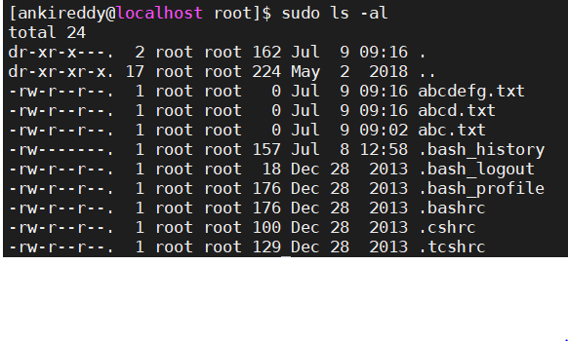**'ls -a'** gives detailed information of the hidden files.



# Deleting files:

**$ rm filename**

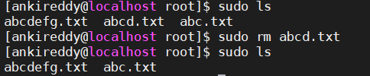

# Making Directories:

**$ mkdir directoryname** creates directory

**$ rmdir directoryname** removes directory

Let’s see how it works

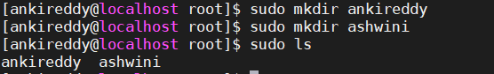



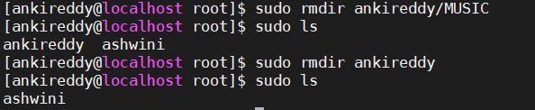

# Renaming Directory:

The 'mv' (move) command can be used for renaming directories. Use the below-given format:

**$ mv directoryname newdirectoryname**

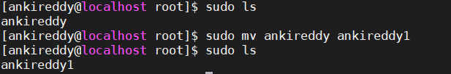

# The ‘man’ command:

To get help on any command that you do not understand, you can type



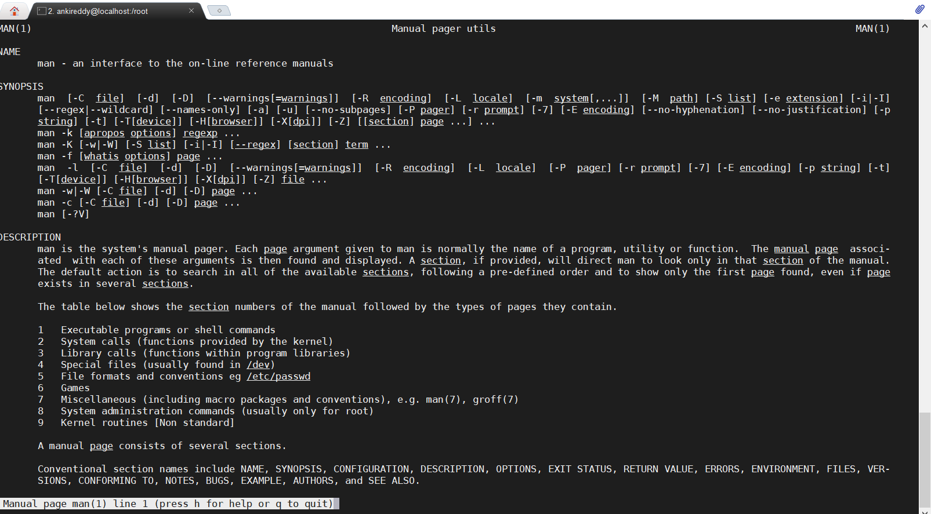

# The History command:

History command shows all the commands that you have used in the past for the current terminal session. This can help you refer to the old commands you have entered and re-used them in your operations again.

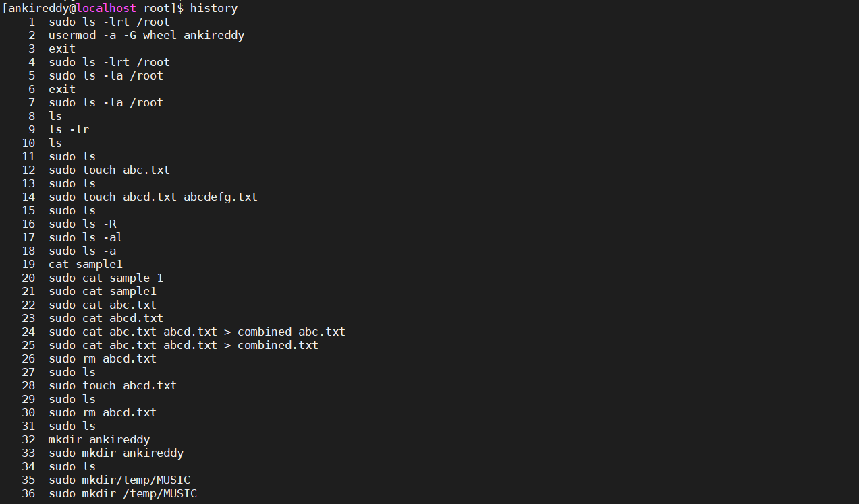

Clear Command:



